EXP -6 Fibonacci series using Recursion
#include <stdio.h>
int fibonacci(int n)
{
if (n == 0)
return 0;
else if (n == 1)
return 1;
else
return fibonacci(n - 1) + fibonacci(n - 2);
}
int main()
{
int n, i;
printf("Enter the number of terms: ");
scanf("%d", &n);
printf("Fibonacci Series: ");
for (i = 0; i < n; i++)
{
printf("%d ", fibonacci(i));
}
return 0;
}
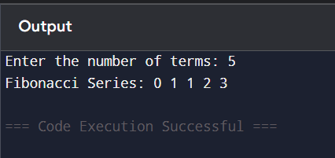
EXP – 7 Insertion of a New Node at the Beginning of a Singly Linked List
#include <stdio.h>
#include <stdlib.h>

struct Node
{
int data;
struct Node *next;
};

struct Node *head = NULL;

void insertBeginning(int value)
{
struct Node *newNode;

newNode = (struct Node *)malloc(sizeof(struct Node));
newNode->data = value;
newNode->next = head;
head = newNode;
}

void insertEnd(int value)
{
struct Node *newNode, *temp;

newNode = (struct Node *)malloc(sizeof(struct Node));
newNode->data = value;
newNode->next = NULL;

if(head == NULL)
{
head = newNode;
}
else
{
temp = head;

while(temp->next != NULL)
{
temp = temp->next;
}

temp->next = newNode;
}
}

void insertAtPosition(int value, int pos)
{
struct Node *newNode, *temp;
int i;

newNode = (struct Node *)malloc(sizeof(struct Node));
newNode->data = value;

if(pos == 1)
{
newNode->next = head;
head = newNode;
return;
}

temp = head;

for(i = 1; i < pos - 1 && temp != NULL; i++)
{
temp = temp->next;
}

if(temp == NULL)
{
printf("Invalid Position\n");
return;
}

newNode->next = temp->next;
temp->next = newNode;
}

void display()
{
struct Node *temp = head;

printf("Linked List: ");

while(temp != NULL)
{
printf("%d -> ", temp->data);
temp = temp->next;
}

printf("NULL\n");
}

int main()
{
int choice, value, pos;

do
{
printf("\n--- LINKED LIST INSERTION OPERATIONS ---\n");
printf("1. Insert at Beginning\n");
printf("2. Insert at End\n");
printf("3. Insert at Any Position\n");
printf("4. Display\n");
printf("5. Exit\n");
printf("Enter your choice: ");
scanf("%d", &choice);

switch(choice)
{
case 1:
printf("Enter value: ");
scanf("%d", &value);
insertBeginning(value);
break;

case 2:
printf("Enter value: ");
scanf("%d", &value);
insertEnd(value);
break;

case 3:
printf("Enter value: ");
scanf("%d", &value);
printf("Enter position: ");
scanf("%d", &pos);
insertAtPosition(value, pos);
break;

case 4:
display();
break;

case 5:
printf("Exiting...\n");
break;

default:
printf("Invalid Choice\n");
}

} while(choice != 5);

return 0;
} ();
return 0;
} 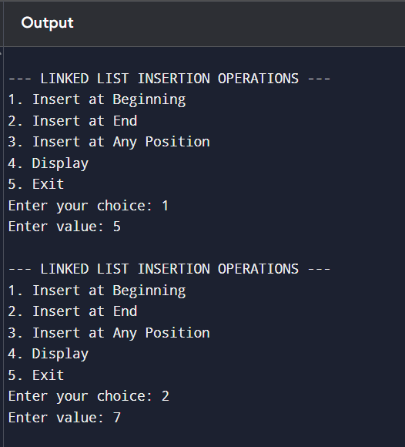

EXP – 8 Insertion of a New Node at the End of a Singly Linked List
#include <stdio.h>
#include <stdlib.h>

struct node
{
int data;
struct node *next;
};

int main()
{
struct node *head = NULL, *newnode, *temp;
int n, i, value;

printf("Enter number of nodes: ");
scanf("%d", &n);

for(i = 1; i <= n; i++)
{
printf("Enter value: ");
scanf("%d", &value);

newnode = (struct node *)malloc(sizeof(struct node));
newnode->data = value;
newnode->next = NULL;

if(head == NULL)
{
head = newnode;
}
else
{
temp = head;
while(temp->next != NULL)
temp = temp->next;

temp->next = newnode;
}
}

printf("Linked List: ");

temp = head;
while(temp != NULL)
{
printf("%d -> ", temp->data);
temp = temp->next;
}

printf("NULL");

return 0;
}

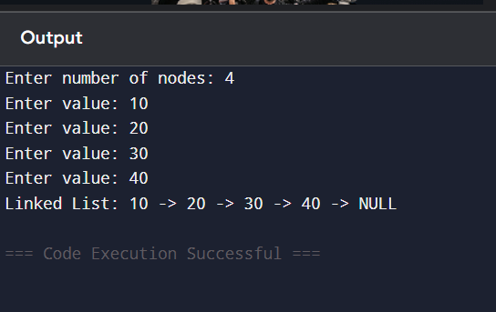
EXP – 9 Insertion of a New Node at the any where of a Singly Linked List
#include <stdio.h>
#include <stdlib.h>

struct node
{
int data;
struct node *next;
};

int main()
{
struct node *head = NULL, *newnode, *temp;
int n, i, value, pos;

printf("Enter number of nodes: ");
scanf("%d", &n);

for(i = 1; i <= n; i++)
{
newnode = (struct node *)malloc(sizeof(struct node));

printf("Enter value: ");
scanf("%d", &newnode->data);

newnode->next = NULL;

if(head == NULL)
head = newnode;
else
{
temp = head;
while(temp->next != NULL)
temp = temp->next;

temp->next = newnode;
}
}

printf("Enter value to insert: ");
scanf("%d", &value);

printf("Enter position: ");
scanf("%d", &pos);

newnode = (struct node *)malloc(sizeof(struct node));
newnode->data = value;

temp = head;
for(i = 1; i < pos - 1; i++)
temp = temp->next;

newnode->next = temp->next;
temp->next = newnode;

printf("Linked List: ");

temp = head;
while(temp != NULL)
{
printf("%d -> ", temp->data);
temp = temp->next;
}

printf("NULL");

return 0;
} 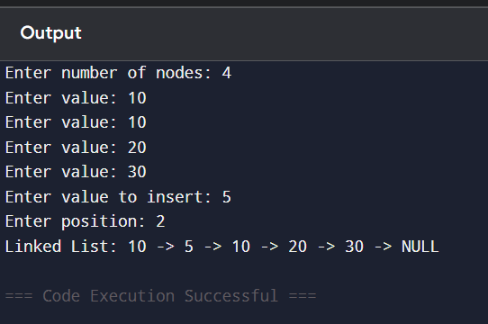

EXP – Array operations Insertion
#include <stdio.h>
int main()
{
int arr[100], n, i, pos, element, choice;
printf("Enter the number of elements: ");
scanf("%d", &n);
printf("Enter the array elements:\n");
for(i = 0; i < n; i++)
{
scanf("%d", &arr[i]);
}
printf("\n1. Insert at Beginning");
printf("\n2. Insert at End");
printf("\n3. Insert at Any Position");
printf("\nEnter your choice: ");
scanf("%d", &choice);
printf("Enter the element to insert: ");
scanf("%d", &element);
switch(choice)
{
case 1: // Insert at Beginning
for(i = n; i > 0; i--)
{
arr[i] = arr[i - 1];
}
arr[0] = element;
n++;
break;
case 2: // Insert at End
arr[n] = element;
n++;
break;
case 3: // Insert at Any Position
printf("Enter the position: ");
scanf("%d", &pos);
for(i = n; i >= pos; i--)
{
arr[i] = arr[i - 1];
}
arr[pos - 1] = element;
n++;
break;
default:
printf("Invalid Choice");
return 0;
}
printf("\nArray after insertion:\n");
for(i = 0; i < n; i++)
{
printf("%d ", arr[i]);
}
return 0;
}
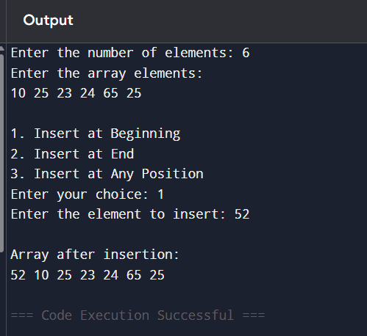
EXP – Array operations in deletion
#include <stdio.h>
int main()
{
int arr[100], n, i, pos, choice;
printf("Enter the number of elements: ");
scanf("%d", &n);
printf("Enter the array elements:\n");
for(i = 0; i < n; i++)
{
scanf("%d", &arr[i]);
}
printf("\n1. Delete at Beginning");
printf("\n2. Delete at End");
printf("\n3. Delete at Any Position");
printf("\nEnter your choice: ");
scanf("%d", &choice);
switch(choice)
{
case 1: // Delete at Beginning
for(i = 0; i < n - 1; i++)
{
arr[i] = arr[i + 1];
}
n--;
break;
case 2: // Delete at End
n--;
break;
case 3: // Delete at Any Position
printf("Enter the position to delete: ");
scanf("%d", &pos);
for(i = pos - 1; i < n - 1; i++)
{
arr[i] = arr[i + 1];
}
n--;
break;
default:
printf("Invalid Choice");
return 0;
}
printf("\nArray after deletion:\n");
for(i = 0; i < n; i++)
{
printf("%d ", arr[i]);
}
return 0;
}
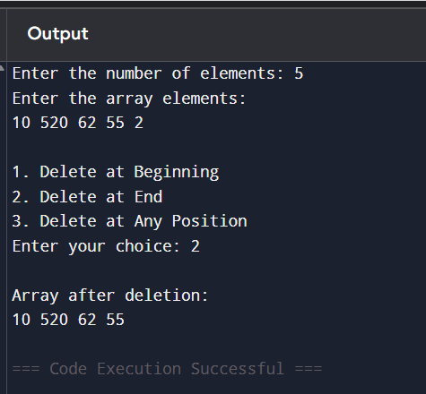
EXP - Stack operations such as PUSH, POP and Display
#include <stdio.h>
#define MAX 5
int stack[MAX];
int top = -1;
void push()
{
int item;
if(top == MAX - 1)
{
printf("Stack Overflow\n");
return;
}
printf("Enter element to push: ");
scanf("%d", &item);
top++;
stack[top] = item;
printf("%d pushed into stack\n", item);
}
void pop()
{
if(top == -1)
{
printf("Stack Underflow\n");
return;
}
printf("Deleted element: %d\n", stack[top]);
top--;
}
void display()
{
int i;
if(top == -1)
{
printf("Stack is Empty\n");
return;
}
printf("Stack elements are:\n");
for(i = top; i >= 0; i--)
{
printf("%d\n", stack[i]);
}
}
int main()
{
int choice;
do
{
printf("\n--- STACK OPERATIONS ---\n");
printf("1. PUSH\n");
printf("2. POP\n");
printf("3. DISPLAY\n");
printf("4. EXIT\n");
printf("Enter your choice: ");
scanf("%d", &choice);
switch(choice)
{
case 1:
push();
break;
case 2:
pop();
break;
case 3:
display();
break;
case 4:
printf("Exiting...\n");
break;
default:
printf("Invalid Choice\n");
}
} while(choice != 4);
return 0;
}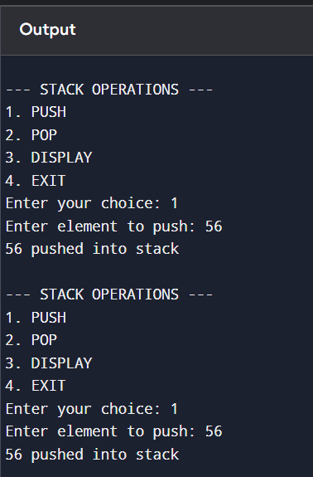

Stack Operations Using Array
Aim
To perform stack operations (Push, Pop, and Display) using an array.
#include <stdio.h>

#define MAX 5

int stack[MAX];
int top = -1;

void push()
{
int x;

if(top == MAX - 1)
{
printf("Stack Overflow\n");
}
else
{
printf("Enter element: ");
scanf("%d", &x);

top++;
stack[top] = x;

printf("Element inserted successfully\n");
}
}

void pop()
{
if(top == -1)
{
printf("Stack Underflow\n");
}
else
{
printf("Deleted element: %d\n", stack[top]);
top--;
}
}

void display()
{
int i;

if(top == -1)
{
printf("Stack is Empty\n");
}
else
{
printf("Stack elements are:\n");

for(i = top; i >= 0; i--)
{
printf("%d\n", stack[i]);
}
}
}

int main()
{
int choice;

do
{
printf("\n1.Push\n2.Pop\n3.Display\n4.Exit\n");
printf("Enter your choice: ");
scanf("%d", &choice);

switch(choice)
{
case 1:
push();
break;

case 2:
pop();
break;

case 3:
display();
break;

case 4:
printf("Exiting...");
break;

default:
printf("Invalid Choice");
}

} while(choice != 4);return 0;
OUTPUT
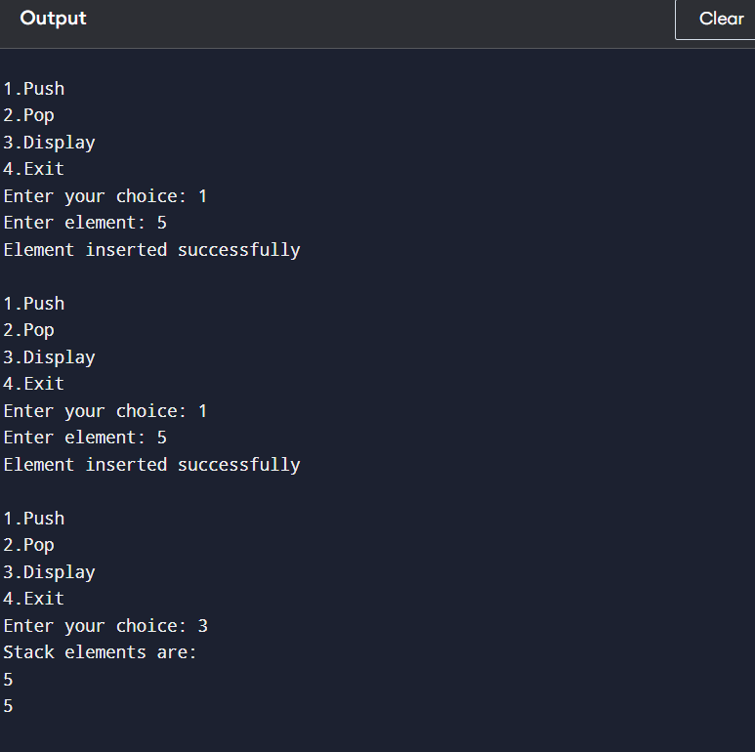
Stack Operations Using Linked List
#include <stdio.h>
#include <stdlib.h>

struct Node
{
int data;
struct Node *next;
};

struct Node *top = NULL;

void push()
{
struct Node *newNode;
int value;

printf("Enter element: ");
scanf("%d", &value);

newNode = (struct Node *)malloc(sizeof(struct Node));

newNode->data = value;
newNode->next = top;
top = newNode;

printf("Element inserted successfully\n");
}

void pop()
{
struct Node *temp;

if(top == NULL)
{
printf("Stack Underflow\n");
return;
}

temp = top;
printf("Deleted element: %d\n", top->data);

top = top->next;
free(temp);
}

void display()
{
struct Node *temp;

if(top == NULL)
{
printf("Stack is Empty\n");
return;
}

printf("Stack elements are:\n");

temp = top;

while(temp != NULL)
{
printf("%d\n", temp->data);
temp = temp->next;
}
}

int main()
{
int choice;

do
{
printf("\n1.Push\n2.Pop\n3.Display\n4.Exit\n");
printf("Enter your choice: ");
scanf("%d", &choice);

switch(choice)
{
case 1:
push();
break;

case 2:
pop();
break;

case 3:
display();
break;

case 4:
printf("Exiting...\n");
break;

default:
printf("Invalid Choice\n");
}
} while(choice != 4);

return 0;
}

OUTPUT
